# Computer Vision Hw7 Report

* Discription
  + Thinning
* Algorithm
  + Original 512x512 image
  + Thinning algorithm in ppt
* Parameters (if any)
  + no
* Principal Code Fragment

Main (file – /src/hw7/ DemoThinning.java)

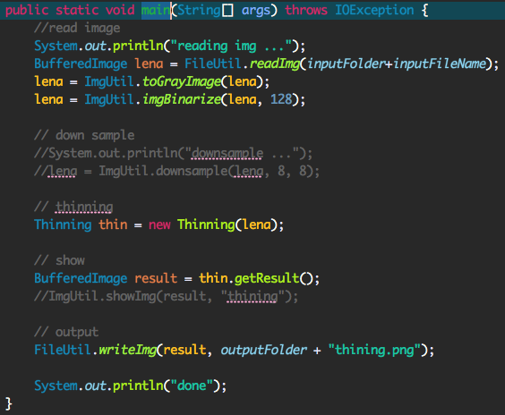

Thinning

(file – /src/cv1.util.cv /Thinning.java)

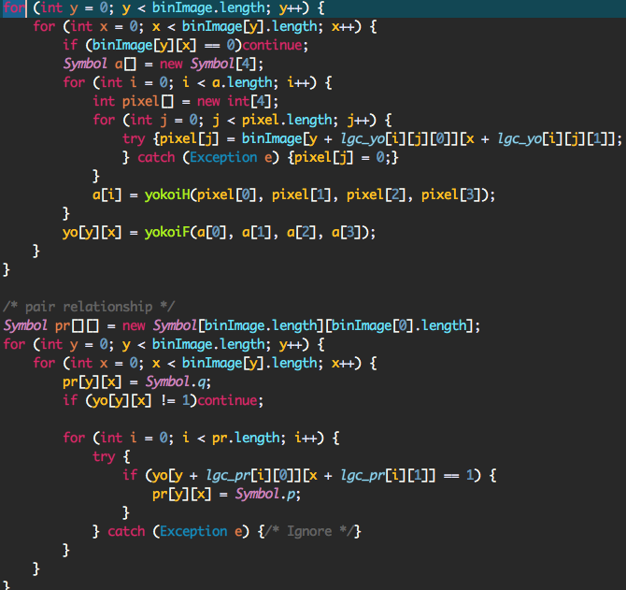

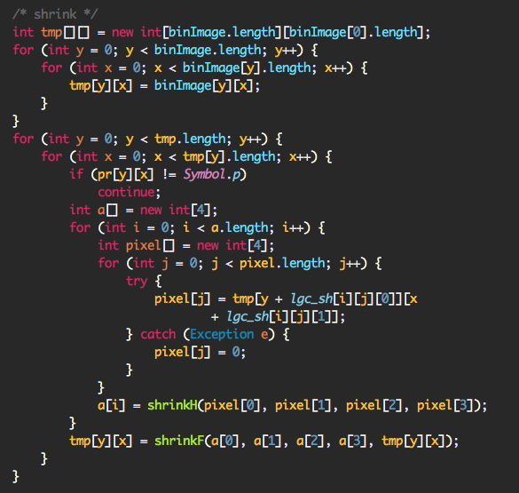

* Result Image

